1. Create the following web page

-Fonts used: Consolas, Edwardian Script ITC

-Color: #0094ff  
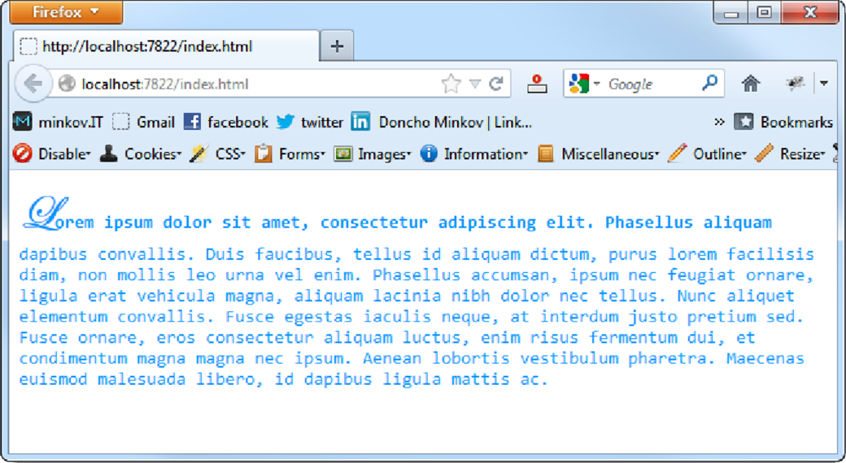

2. You are given prewritten HTML and CSS code. Expand this code to make the web page to look exactly like the PNG image: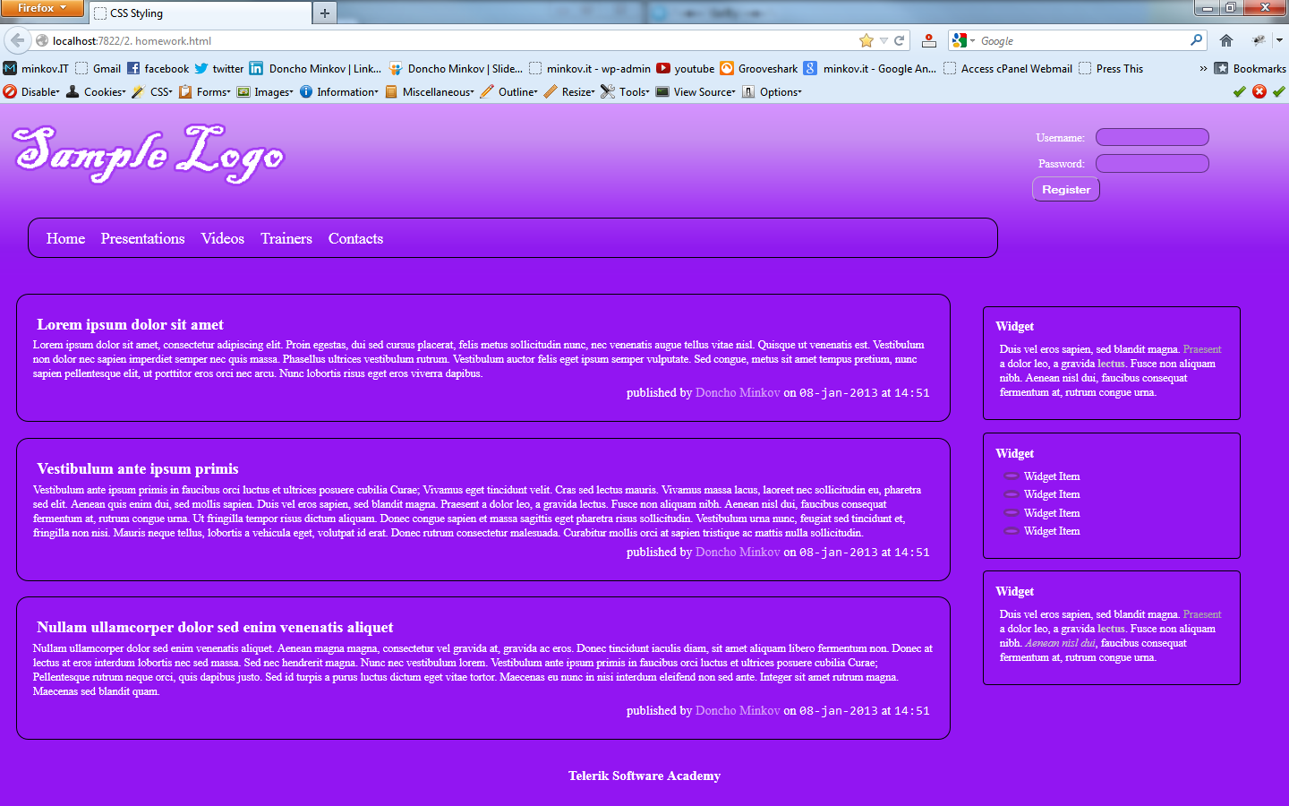

1. Create the following web page

-Using 60 nested div elements  
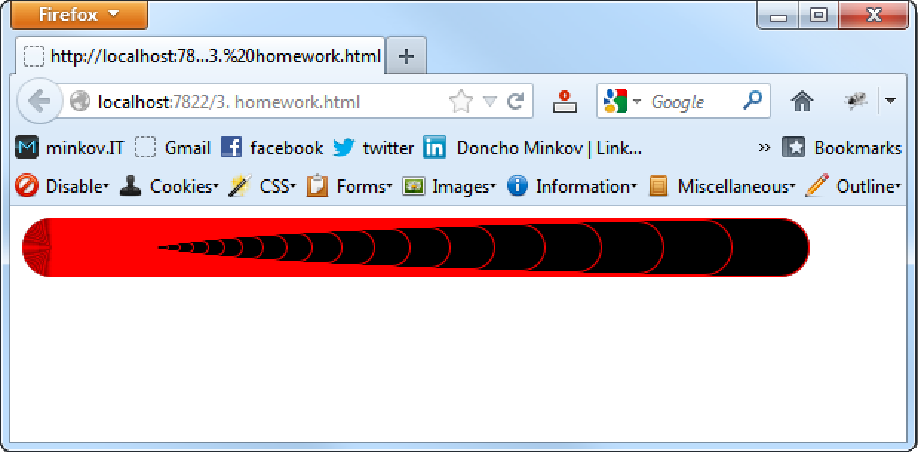

1. Create a web page that looks like the Windows calculator in Programmer view

-It should look exactly   
the same

-Implement hover effects   
for the buttons

-The calculator should   
not have any functionality  
